Post-Vaccination Models of SARS-2-Cov Epidemics

With

CovidSIMVL and BNT126b2

Ernie Chang MD PhD; Ken Moselle PhD

April 26 2021

**INTRODUCTION**

We present simulation models of course of Covid epidemics using the parameters of the Pfizer BNT126b2 vaccine as an exemplar, using parameters as set out in its EUA.

The approach we take is to set the simulation parameters for 1,000 persons such that without vaccine they will all be infected with a single initial case. We then introduce vaccinations of numbers of persons in compliance with the efficacies as given, and compare the simulations to the expected numbers of protected, to produce simulated effectiveness levels.

**Disjunctive vs Conjunctive Interpretations of Efficacy**

The precise definition of “efficacy” relates to the results of clinical trials, comparing the effect of the vaccine on the attack rates of a treated population compared to those of a placebo group. Another way of stating this is that an efficacy of 90% means that there is a 90% reduction in the expected number of cases.

This is a population-based interpretation rooted in the production of antibodies to a level high enough that 90 of 100 expected infected persons are protected. It does not state who the unlucky 10 are. So this is not a personal level of production – you don’t know which group you are in, but the personal protection is binary – either your levels are such that you are protected, or not. Hence we call this the **disjunctive model.**

90% vax

10% not protected

Most conversations about the protective level of vaccines do not present this stark division (which may not necessarily be fixed by person, but fluctuate as long as the overall rate is respected), but adopt a personal view that “now that I have the vaccine, I am protected”. What then would a 90% protection level mean? We model this view by considering, whenever there is a potential infection event (between an infective and a susceptible), that there is a 90% probability that the infection will fail.

The problem with this approach is that if a susceptible is exposed to multiple infective challenges, each at 90% probability of failure, sooner or later the odds will catch up (0.9**n). Cumulative successive challenges reduce the overall protection to something less than 90%. This leads us to call this the ***conjunctive model.***

p(0.9) protection each challenge

90% vax

Therefore, we will use both models in our simulations, and then compare them. The Discussion section will consider whether the reality is some blend of the two, as the conjunctive model may reflect individual and specific heterogeneous environmental factors.

**METHODOLOGY**

Establishing the vaccination parameters and doing the vaccination is a two-step process. The first is to use the parameter.csv file to define vaccine-specific parameters as shown below:



The first line establishes this as a ***parameter file.***

The next lines till “VAX” establishes the parameters for a specific Universe, in this case U0.

The VAX lines describe the time from vaccination to reach Level.P1 which for the Pfizer disjunctive case is 0, and Level P1 would be set to 1.00. In this case, for a Conjunctive trial, the T.eff1 day is set to 10, and the Level.P1 is set to 0.905.

In the Conjunctive framework, each day from T=0 to T=T.eff1 sees a linear increase in p(protection) from 0 to Level.P1.

T.dec is the Day at which the vaccine starts decreasing in efficacy, in this case 120 as for the BC strategy for vaccination. The T.res is the Day at which the efficacy drops to its residual level p(0.25).

Parameters not shown here would be for the second dose (injection): T.dose2, the time it takes to reach effectiveness, T.int2, and the increase in efficacy when it reached T.int2 which is T.delta2. These will be addressed in a subsequent study.

With the parameters as given above, we can support Disjunctive and Conjunctive vaccine models, as well as being able to compare within models the effects of decreasing or increasing the number of days at which the vaccine remains effective after one dose. We used a single Universe of 1,000 age-neutral agents.

The second step is to do the actual vaccination for the population. This is described below, with Disjunctive requiring two vaccinations – one for the first dose to the time it reaches T.eff1 which is Day.21, and the second at Day 21. This is due to our approach of vaccinating the protected sub-population at 100% at Dose1, which is 52% of the expected (see Appendix 1 below), and then 82% of the expected infected from Day.21 on.

**Implementation of the Disjunctive Model**

To implement 90% efficacy we find the number expected to have been infected, and we assign to 90% of that population a binary-level protection of TOTAL PROTECTION (100%) and the other 10% we leave as UNPROTECTED.

We do this at the various milestones of the Pfizer EUA, for one dose at this time, in part for proof by example, and in part because the current strategy adopted in many countries is to delay the second dose to 90 or 120 days.

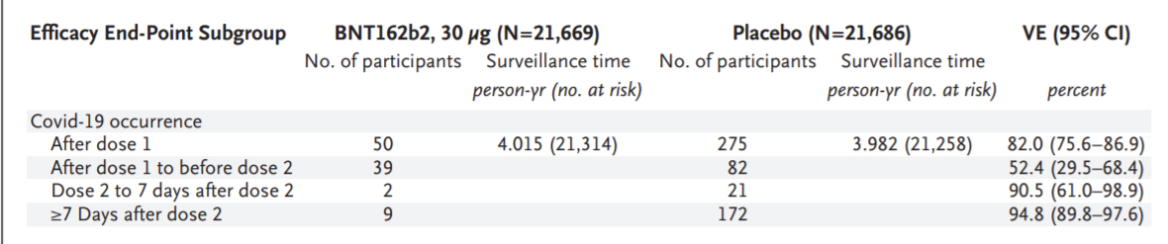

These data, from the NEJM discussion of Pfizer BNT126b2 (Polack et al. NEJM 2020;383:2603-15), is the key to our modelling of both the disjunctive and conjunctive approaches.

The following summary describes how we implement the information above into vaccination schedules and cohorts. We chose to start at generation0, but could slide the start of vaccination to any generation, discounting the already infected by vaccination date. This we leave for a future exercise.

If we use these numbers, we are vaccinating 100% of the population of 1,000.

To obtain the trials for vaccinating a different % of the population, we have taken a linear factor as multiplier, so that for 50% vaccination of the population, we use 52% of 139, and 82% of 861, which yields 72 and 690 respectively on days D.0 and D.21.

The results of these calculations and trials are shown in the table and chart below. They show the expected number of uninfected versus the number from the simulations.



The row “D0 Full Protection” shows the numbers protected (at the 100% parameter level) on D.0 (first dose). The next row show the numbers protected on D.21, for each of the columns which show the percentage of the population of 1,000 that are vaccinated. These column numbers are just a linear fraction of the 100% population column.

To explain this from another approach, CovidSIMVL has a set of parameters for the probability of an infective encounter failing. If this is set to 1, then no encounters will succeed. The implementation of the Disjunctive model is to use this parameter setting to fully protect the percentage of the affected in a certain period (the efficacies reported in the NEJM article). That gives compliance with the definition of efficacy – the proportion of those protected of the expected infections in a period.

The sum of the two vaccinations (done manually through the GUI interface in CovidSIMVL in the Fixed Universe interface) is given the row “Total Protected” while the next row gives the actual uninfected resulting from the simulation trial. This can be interpreted to be simulations of the actual effectiveness in the population during the epidemic, compared to the efficacy and the theoretical effectiveness. In the case of the 100% population using a single dose and 52% efficacy from D.0 to D.21 and 82% after, the theoretical effectiveness would be 76.2% (third last row – Total Protected) while the simulation effectiveness in 91.8%. The results for these trials are shown in the chart below, which reports the numbers uninfected in days after the Dose.1.

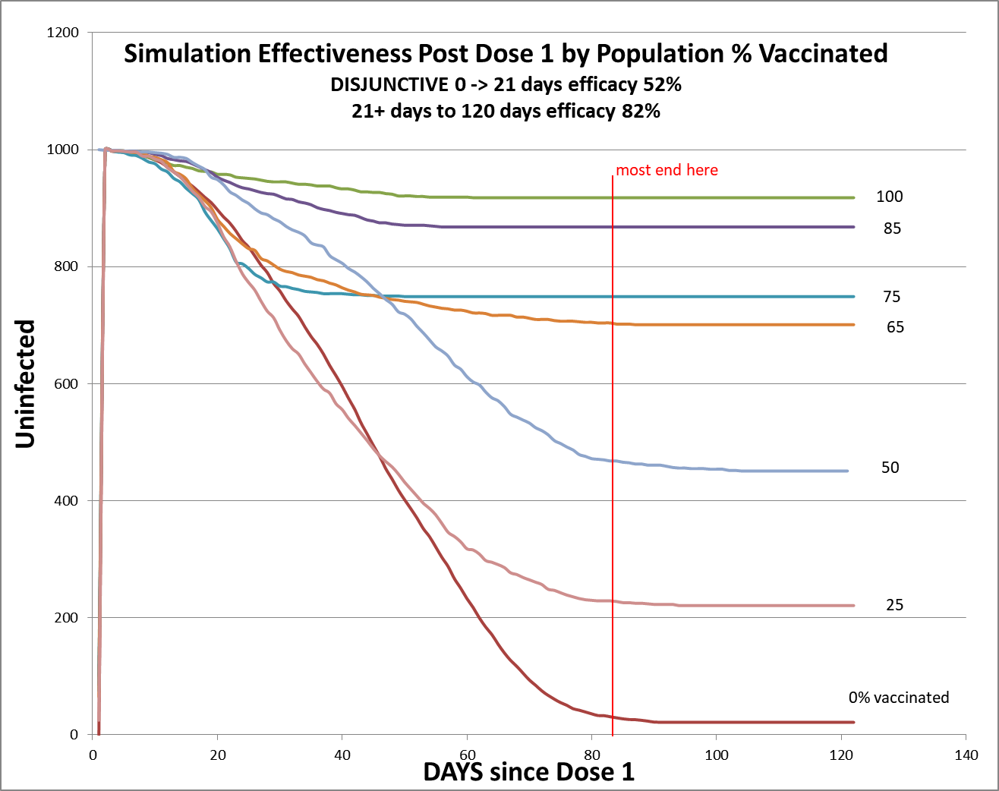

A caveat: although the days run to 180, in most of these trials self-termination (no further infective persons) occurred before 120 days, so the interpretation is that the secondary effects of having fully protected persons interfered with the ability of infectives to find susceptibles at a rate sufficient to maintain the epidemic.

The general observation here is that the level of protection of for population vaccinations from 65% and upwards is around 70% (700/1000) to Day 82, and that there is a real benefit of about 75% compared to no vaccination to Day.50 for all except 0% and 25% population vaccinated.

We now turn to the Conjunctive approach, which is a personal level protection, rather than the population approach in Disjunctive.

**Conjunctive Implementation**

The structure of the vaccine parameters in CovidSIMVL (refer to first table) permit us to define the ramp-up period between zero and attained level of probability of protection, as well as that level, and the duration of that level before it declines, and the duration of that decline till it reaches a residual level.

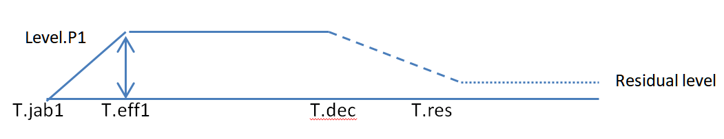

We have several alternatives in implementing this model given the NEJM data. The choices for the ramp-up period and the attained protection Level.P1 are:

1. 21 days (between dose1 and dose2) at 52.4%; but CovidSIMVL ramps up on a daily basis linearly
2. 21 days at 82.0% where this is the protection “After dose1” for the entire period
3. 21 days ramp up to 90.5% since this is the level attained before dose2 effect is fully present
4. Based on the chart from NEJM below, choose 10 days of ramp-up to an effective level of 90.5%

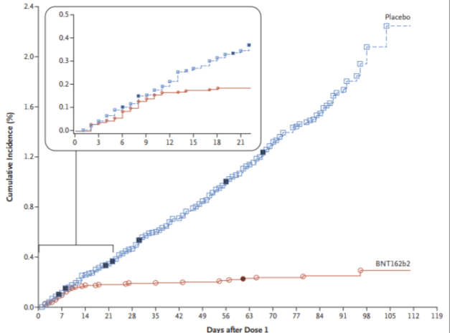

We chose to run trials using:

b – 21 days ramp to 82%

c – 21 days ramp to 90.5%

d- 10 days ramp to 90.5%

The calculation for the expected number of protected persons for the Conjunctive approach is much the same. If there is no vaccination, then the epidemic parameters as given provide the numbers for days according to Appendix 1.

If there is 100% vaccination and 82% protection, the ramp up protection over 21 days is the average to the level of 82% over 21 days, which is with 41% (half of 82%) of 139.

Our justification for adopting the 90.5% level of protection is that the Conjunctive model, as a personal level, is the probability used in every infection challenge. The overall effectiveness (experienced protection) is going to be lower, based on the notion that to survive k challenges, each call to the random number has to return a number > 0.9, and to have a k-length sequence each > 0.9 is to have a conjoint probability of (0.9**k).

The other important thing to note is that in Conjunctive approach, we select a number in the population corresponding to the numbers to be vaccinated. If we want 100% vaccination, we select 1,000 persons at Dose 1. In these trials, for both approaches we have used Generation 0 as the start of vaccination.

Thus, in Conjunctive, we select a cohort to experience Vaccine properties, whereas with Disjunctive, we select an expected number for a cohort to obtain FULL PROTECTION.

The other important parameter that we use in all the trials is the Day at which the effectiveness starts declining, which is 120 for all of them, and the Day at which Residual Protection (25% for all) is attained, and the difference this makes is that we use a linear decline, so each day following T.dec (decline) the protection is less for all challenges, including in the Disjunctive model. In general, the residual Day has been set to 180 or more.

**CONJUNCTIVE MODEL RESULTS**

We use as the primary approach to comparing these trials, their experience in protection, that is, the count of uninfected persons at the end of the trials (when there are no more possible infectives). We use the experienced numbers, and compare these to the expected numbers (from Appendix 1), to estimate their ***effectiveness*** in the simulated real-world. Then we can compare these ***effectiveness scores*** to each other.

The other approach is not to use a common time-marker to assess the progress of the simulated epidemics and the level of protection provided with these different strategies. This we will do, and add to the report.

The Expected Number of uninfected for the p(0.82) approach is exactly the same as in the Disjunctive Model for which we used p(0.82) according to the NEJM data. For the p(0.905) model, we used the same calculations substituting the 0.905 for 0.82 to arrive at 819 for the 100% population vaccination expected number of uninfected.

Conjunctive Model b – 21 days ramp to 82%



Conjunctive Model c – 21 days ramp to 90.5%



Conjunctive Model d – 10 days ramp to 90.5%



First, there is a marked difference in both effectiveness and delta-effectiveness over theoretical when comparing probability level of 82% to 90.5%. Secondly, 10 day ramp and 21 day ramp are similar with population vaccination to 75%, less than which the 10 day ramp shows as being less effective.

Similar observations can be seen when tracking daily uninfected numbers in each of the three cases, as show below.

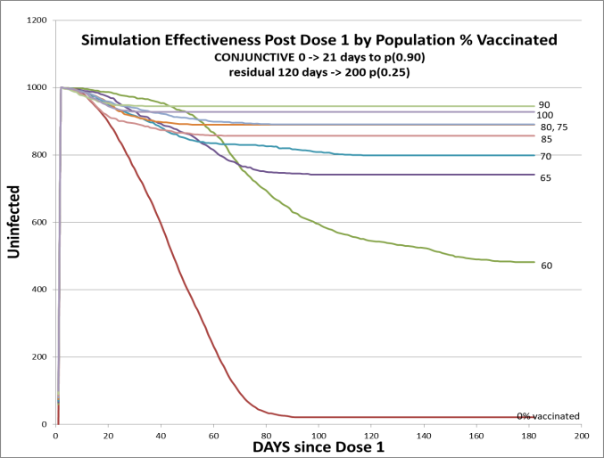The Time-Marker charts

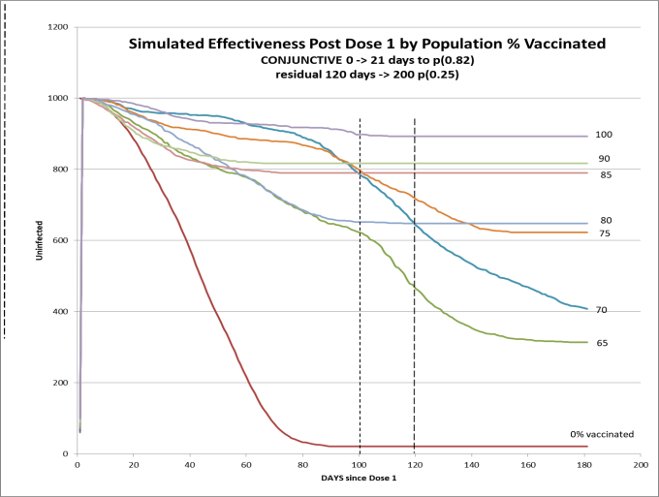 Scenario b – 21 day ramp to p(0.82) Scenario c – 21d ramp to p(0.90)

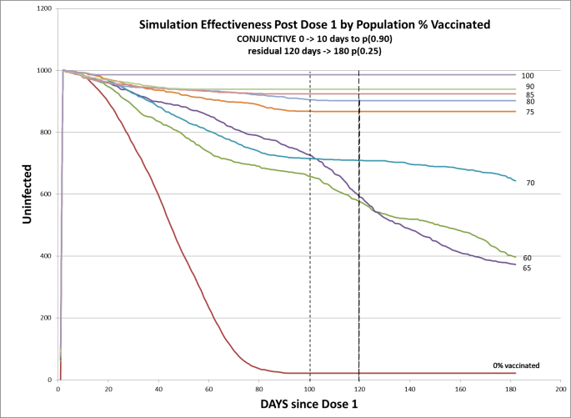

Scenario d – 10day ramp to p(0.90)

The right vertical line is 120 days, and the left is around 100 days, showing the time at which most trials with different populations vaccinated provide effectiveness at 70% or more.

**DISCUSSION**

In comparing the Disjunctive and Conjunctive models, the most striking thing is how similar they are in general. Looking for detailed differences, it would seem that the Disjunctive Models terminate sooner, achieving an effectivenss of 70% or more for population vaccinations of 65% or higher within 50 days.

The Conjunctive approach gives better results when the ramp up is lower and the probability level of protection is higher (10 days to p0.9 is best), with population vaccinations of 75% and above achieving effectiveness near 90% or more.

These similarities state that if the population is vaccinated to the 70% - 80% level, then whether Disjunctive or Conjunctive actually operates, the effectiveness of protection achieved is 70% or higher.

The differences between the two models are inherent in the way we deal with likelihood of an encounter leading to an infection. Using Disjunctive approach, only the population not vaccinated can contribute to new infections, whereas in the Conjunctive approach, all individuals may be infected, depending on their assigned probability of protection. Thus, the Disjunctive model has a smaller population of unprotected, and a larger cohort of totally protected, which gives, at higher population levels of vaccination, a differential exposure of the unprotected to the infectives. It will take a shorter period of time to run out of likely susceptibles, before the life-time of the infective runs out.

The Conjunctive model, on the other hand, exposes every person to possible infection (unless the probability of 1 was chosen), and therefore the creation of new infectives may take longer, because of the partial protection, as compared to the Disjunctive, in which susceptibles have no protection.

SUMMARY

This study is motivated in part by the desire to model effectiveness in simulated epidemics as compared to the efficacy given in theory from Phase3 studies, as in Pfizer. We have done this, while diving into the apparent disjoint views of population protection (the Disjunctive Model based on efficacy) versus the popular interpretation of vaccination, which is that everyone enjoys a personal level of protection.

So far, we have taken the two viewpoints as separate approaches, and have not tried to blend them into a unified model. Neither have we, as yet, modelled the two Dose regimen to a level of 95% efficacy, in part because the timeliness of delaying second injections to 120 days is an urgent call to understand what the ramifications might be. Nor have we staged vaccination schedules as yet, rather taking the purist view that if we could vaccinate the desired population at once, we could study the effects in a simpler way without losing generality, ceteris puribus.

The answer to that dominant question of the best strategy, appears to be: get 75% of the population vaccinated as quickly as possible with one dose.

APPENDIX 1. TRIALS of No Vaccine to Self-Terminate

Expected number of infections from D.0 to D.21 = 139

Expected additional number from D.21 to termination = 978 – 139 = 839